Shattered Protocols Test Report 3.0, Unit Test Focus
Report covers the testing scope, test schedule, product features and quality, a list of all flags remaining open with a RISK assessment, and lessons learned.
Test Report
- Project Title: Shattered Protocols
- Test Report Scope: Report on the increments 1, 2, 3 and 4 testing associated with release 1 and 2 testing, and system testing.
- Test team: Seth Welton
- Test Schedule:
  - Iteration 1.0 finished on 4 Nov 2024
  - Iteration 2.0 finished on 14 Nov 2024
  - Iteration 3.0 will be finished on 20 November 2024
- Test Description: describe each test, what was tested and the test outcome:
a. To make sure newly implemented locks work in each room
- Test if lock prevents travel if in locked state and puzzle is not solved:
-R0 = Front Desks: Success
-R1 = Meeting Room: Success
-R2 = Development Lab: Success
-R3 = Heart of Operations: N/A
-R4 = Testing Lab: Success
-R5 = Break Room: N/A
-R6 = Server Room: Success

- Test if solving the puzzle unlocks the door:
-R0 = Front Desks: Success
-R1 = Meeting Room: Success
-R2 = Development Lab: Success
-R3 = Heart of Operations: Success, it ends game correctly
-R4 = Testing Lab: Success
-R5 = Break Room: N/A
-R6 = Server Room: Success

- Test if lock ONLY prevents access to room it is supposed to be locking and no other room:
-R0 = Front Desks: Success
-R1 = Meeting Room: north works as expected, but west should NOT be preventing access as there is no lock preventing Meeting Room (R1) -> Development Lab (R2). 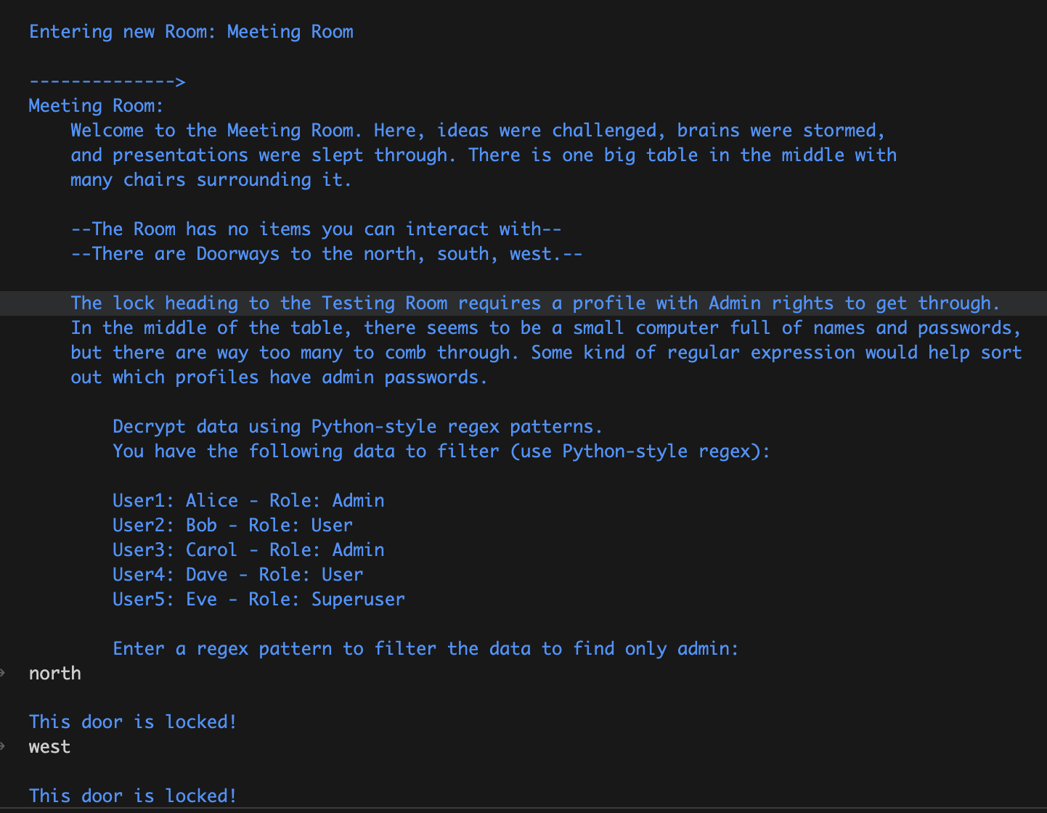
-R2 = Development Lab: Success
-R3 = Heart of Operations: N/A
-R4 = Testing Lab: west works as expected, but east should NOT be preventing access as there is no lock preventing Testing Lab (R4) -> Server Room (R6). 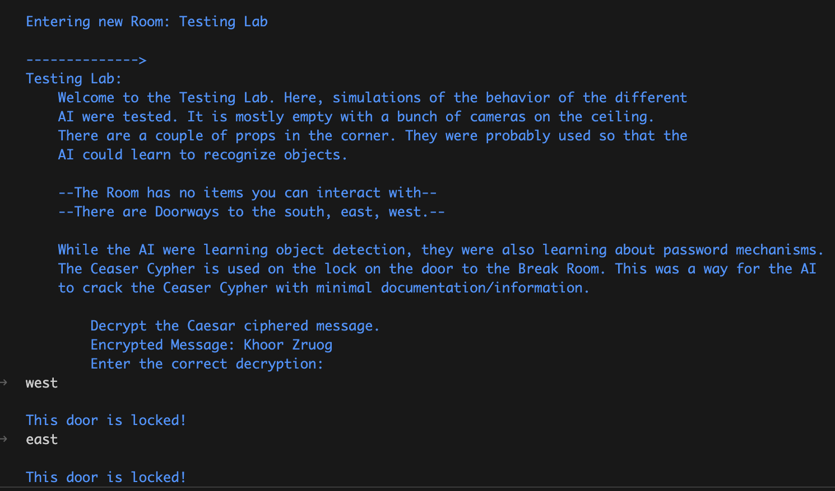
-R5 = Break Room: N/A
-R6 = Server Room: Success

b. To make sure text is properly wrapped and looks good in each room
- Test each Room Intro, Room Description (as in which way you can go and if there are items), and Puzzle Intro to see if they wrap nicely:
-R0 = Front Desks: Success
-R1 = Meeting Room: Success
-R2 = Development Lab: Success
-R3 = Heart of Operations: Success
-R4 = Testing Lab: Success
-R5 = Break Room: Success
-R6 = Server Room: Success

- Test each Puzzle Hint to see if it wraps nicely:
-R0 = Front Desks: Success
-R1 = Meeting Room: Success
-R2 = Development Lab: Success
-R3 = Heart of Operations: Success
-R4 = Testing Lab: Success
-R5 = Break Room: N/A
-R6 = Server Room: Success

- Test each Puzzle Outro to see if it wraps nicely
-R0 = Front Desks: Success
-R1 = Meeting Room: Cannot test as puzzle is not solvable yet
-R2 = Development Lab: Cannot test as puzzle is not solvable yet
-R3 = Heart of Operations: Success
-R4 = Testing Lab: Success
-R5 = Break Room: N/A
-R6 = Server Room: Success

c. To make sure ducky_flash_drive can be picked up in Break Room (R5) and used in Heart of Operations (R3) to finish final puzzle
- Test if ducky_flash_drive can be picked up using keyword: take:
-R0 = Front Desks: N/A
-R1 = Meeting Room: N/A
-R2 = Development Lab: N/A
-R3 = Heart of Operations: N/A
-R4 = Testing Lab: N/A
-R5 = Break Room: Success
-R6 = Server Room: N/A

- Test if ducky_flash_drive is in inventory after take with keyword: inventory:
-R0 = Front Desks: N/A
-R1 = Meeting Room: N/A
-R2 = Development Lab: N/A
-R3 = Heart of Operations: N/A
-R4 = Testing Lab: N/A
-R5 = Break Room: Success
-R6 = Server Room: N/A

- Test if ducky_flash_drive enables puzzle in Heart of Operations (R3) after keyword: use ducky_flash_drive:
-R0 = Front Desks: N/A
-R1 = Meeting Room: N/A
-R2 = Development Lab: N/A
-R3 = Heart of Operations: Success
-R4 = Testing Lab: N/A
-R5 = Break Room: N/A
-R6 = Server Room: N/A

- Final product features and quality: describe the final product and any flaws

-The locks are mostly working! There is just a small quirk at the moment where if there is a doorway that needs to be locked, the lock prevents access to all other rooms except the one the player came from. The lock should only prevent access to one specific doorway as defined in the Map Design.

-When trying to solve a puzzle, if the player leaves the room and comes back to try to solve it again, the attemptCount does not reset. This could result in some hints getting buried and the user would be forced to scroll up on the history to try and find a previous hint instead of the puzzle just starting fresh. This is a known bug and fixes are coming soon.

- The ducky_flash_drive is working very well! If we have time after we have a finished product, we are wanting to make the hints be items that the player can pick up, drop, and use instead of being generated from failure attempts.

-The current state of the game is looking promising! The locks are implemented well, and the text wrapping makes the game more readable.

- Test Flags and Risk Management: List all open flaws/flags remaining and provide a RISK assessment for each
-Flaw: Locks are preventing access to rooms it should not. Level of severity: Medium High.
Risk assessment: This will make the Map Design a bit more confusing as there are no locks in certain areas, but access is prevented. This could limit player fun as each puzzle becomes mandatory. The intended way of play is to let the player pick and choose certain puzzles in the event the player gets stuck on one and wants to work on another.
-Flaw: Each room does not have the “try counter” reset. Level of severity: Light.
Risk assessment: The intention was to make the counter reset for a better user experience, but implementation needs a little bit of work. The user could experience mild frustration as the hints don’t reset for the puzzles, but it does not break the game in any way, so it is not too bad.
- Lessons Learned from testing

-When first testing, if there was an unsolvable puzzle, it would impede testing to a halt. However, our development team was very clever in implementing a temporary debugging keyword called solve. Using this keyword allows testing to continue to different parts of the game for testing. This keyword will be removed in the final product, but at the moment, it makes testing faster as the specific answer does not need to be input every time.

